**CLIMATE TRACK SMART USING BLOCKCHAIN**

**A PROJECT REPORT**

**SUBMITTED BY,**

**D.JENIFER JAISTY**

**T.ISHAJOTHI**

**J.DEVA DHARSHINI**

**S.MONISHA**

**TEAM ID: NM2023TMID03128**

**OCT-23**

**JAYARAJ ANNAPACKIAM CSI COLLEGE OF ENGINEERING,**

**NAZARETH-628617**

**CLIMATE TRACK SMART USING BLOCKCHAIN**

**1. INTRODUCTION**

**1.1 PROJECT OVERVIEW**

* Climate Track Smart is a block chain-based platform transparent and verifiable tracking of carbon emissions across supply chains. It uses smart contracts to automate the recording and verification of emissions data, providing a tamper-proof and auditable record of environmental impact.
* The platform is designed to help businesses reduce their carbon footprint and meet their sustainability goals. It can also be used by consumers to make more informed purchasing decisions, and by investors to identify and support sustainable companies.
* Climate Track Smart works by integrating with IOT devices and sensors to collect data on energy consumption, transportation, and other activities that generate emissions. This data is then recorded on the block chain, where it can be accessed and verified by all stakeholders.
* Climate Track Smart is still under development, but it has the potential to revolutionize the way we track and manage carbon emissions. By providing a transparent, accountable, and efficient system for monitoring and reporting on emissions, Climate Track Smart can help businesses, consumers, and investors to play a role in combating climate change.

**1.2 PURPOSE**

* The purpose of climate track smart using block chain is to provide a transparent, tamper-proof, and efficient way to track and manage climate data. This can be used to support a variety of climate change initiatives, such as:
* **Carbon emissions tracking**-Block chain can be used to track carbon emissions across supply chains and value chains, helping businesses and organizations to identify and reduce their carbon footprint.
* **Renewable energy tracking**-Block chain can be used to track the generation and consumption of renewable energy, helping to ensure that renewable energy is properly accounted for and that consumers are able to purchase clean energy.
* **Climate finance**-Block chain can be used to create and manage climate finance markets, making it easier for investors to invest in climate change solutions and for project developers to access the capital they need.

Overall, climate track smart using block chain has the potential to play a major role in helping us to address climate change. By providing a transparent, tamper-proof, and efficient way to track and manage climate data.

**2. LITERATURE SURVEY**



|  |  |
| --- | --- |
|  |  |

**2.1 PROBLEM STATEMENT DEFINITION**

|  |  |  |  |  |
| --- | --- | --- | --- | --- |
| **I am**  **Climate** | **I'm trying to**  Track | **But**  I cannot  Track my climate | **Because**  Climate conditions | **Which makes me**  Feel dull |

* Climate change is one of the most pressing challenges facing our planet today. It is essential that we take action to reduce greenhouse gas emissions and mitigate the effects of climate change. Block chain technology has the potential to play a significant role in this effort.
* One of the key challenges in addressing climate change is the need for transparent and accurate data on greenhouse gas emissions. Block chain can help to address this challenge by providing a secure and tamper-proof way to record and track emissions data. This can help to ensure that all stakeholders are working from the same data set and that progress is being made towards emissions reduction targets.
* Another challenge is the need to incentivize businesses and individuals to reduce their emissions. Block chain can be used to create carbon markets, where businesses and individuals can trade carbon credits. This can help to create a financial incentive for businesses to reduce their emissions and for individuals to make more sustainable choices.
* Block chain can also be used to develop new climate-friendly products and services. For example, block chain can be used to create a decentralized energy grid that is powered by renewable energy sources. can also be used to develop new ways to finance climate-friendly projects.
* Overall, block chain has the potential to play a significant role in addressing climate change by providing a more transparent, accountable, and efficient way to track and manage emissions.

**3. IDEATION AND PROPOSED SOLUTION**

**3.1 EMPATHY MAP CANVAS**

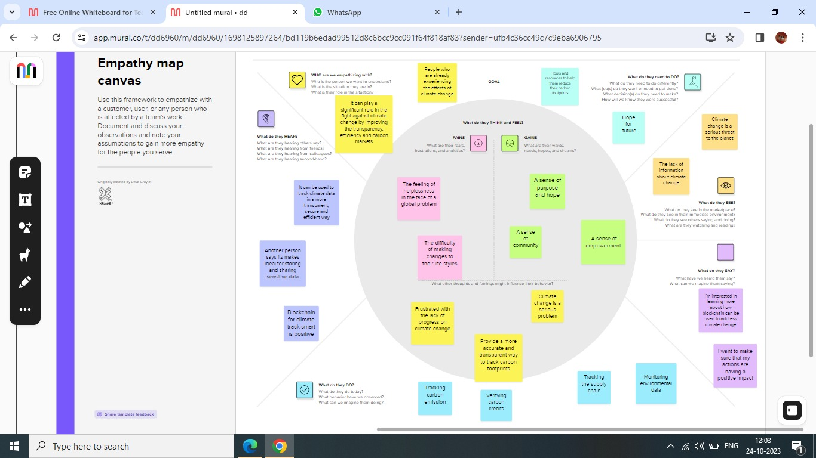

**3.2 IDEATION AND BRAINSTORMING**

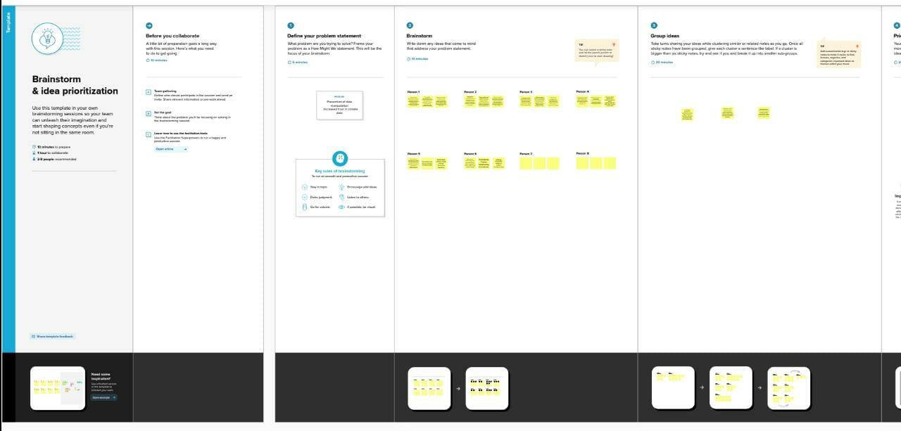

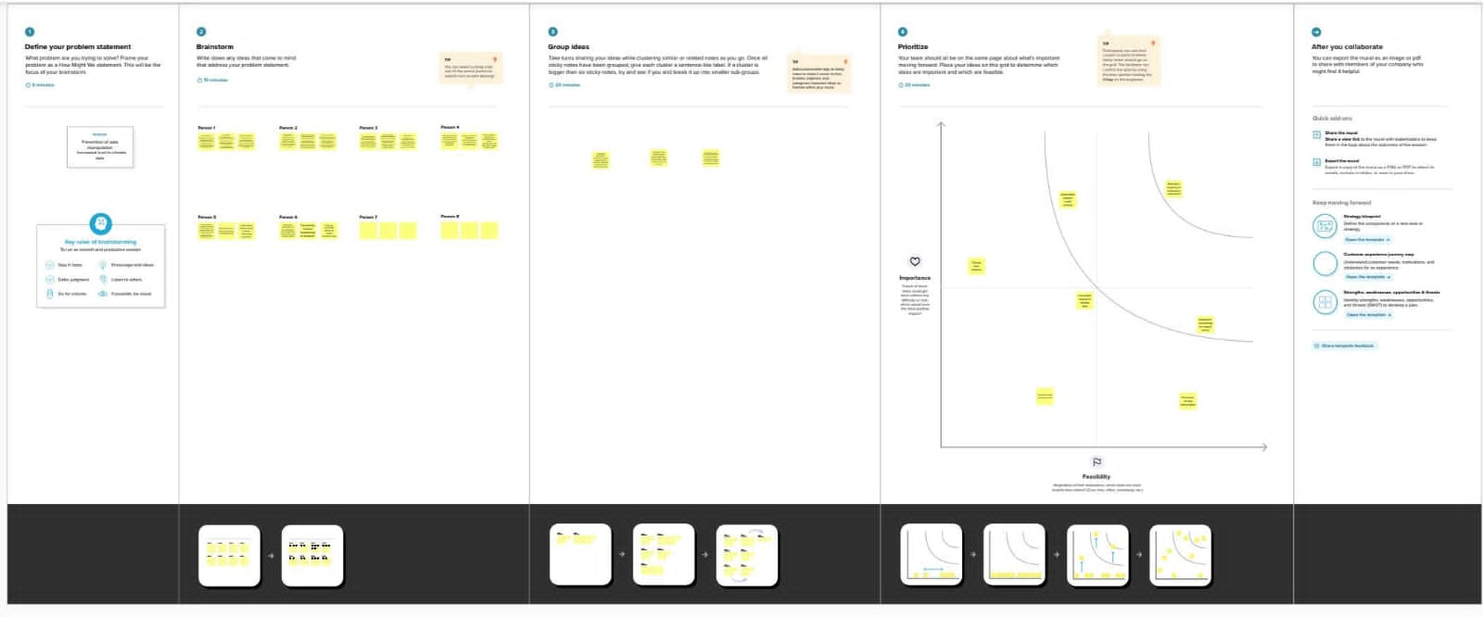

**4. REQUIREMENT ANALYSIS**

**4.1 FUNCTIONAL REQUIREMENTS**

**Data providers:** These are the organizations that will be collecting and providing data to the system. This could include government agencies, businesses, and research institutions.

* **Data users:** These are the organizations that will be using the data in the system. This could include government agencies, businesses, and investors.
* **Regulators:** These are the organizations that will be responsible for overseeing the system and ensuring that it is compliant with all applicable regulations.
* **Data collection:** The system must be able to collect data from a variety of sources, including IOT sensors, government databases, and private company datasets.
* **Data storage:** The system must be able to store the collected data in a secure and tamper-proof manner.
* **Data sharing:** The system must be able to share the collected data with authorized users in a secure and controlled manner.
* **Data analysis:** The system must be able to analyze the collected data to generate insights into climate trends and patterns.
* **Carbon credit management**: The system must be able to track and manage carbon credits, including issuance, transfer, and retirement.

**4.2 NON FUNCTIONAL REQUIREMENTS**

* **Performance:** The system must be able to handle a large volume of data and a large number of users without any significant performance degradation.
* **Availability:** The system must be highly available. so that users can access the data and services they need when they need them.
* **Security:** The system must be secure and protect the confidentiality and integrity of the data it stores.
* **Scalability:** The system must be scalable, so that it can be expanded to meet the needs of a growing user base.

**5. PROJECT DESIGN**

**5.1 DATA FLOW DIAGRAMS & USER STORIES**

**USER STORIES**

* As a carbon offset buyer, I want to be able to verify that the carbon offsets I purchase are legitimate and that the emissions reductions they represent have actually occurred.
* I want to be able to see the full audit trail of each carbon offset, from the point of generation to the point of retirement. I want to be able to be confident that my carbon offsets are not being double-counted or sold to multiple buyers. I want to be able to track the impact of my carbon offsets over time and see how they are contributing to climate change mitigation. As a carbon offset project developer, I want to be able to sell my carbon offsets to buyers in a transparent and efficient way. I want to be able to list my carbon offsets on a block chain-based marketplace where buyers can easily find and purchase them. .
* I want to be able to track the issuance and retirement of carbon offsets to ensure that they are being used in accordance with regulations.
* I want to be able to identify and prevent fraud in carbon offset markets.
* Illustrate some of the specific benefits of using block chain for climate tracking:
* As a carbon offset buyer, I want to be able to purchase carbon offsets directly from farmers and other landowners who are implementing climate-friendly practices.
* I want to be able to support small-scale carbon offset projects in developing countries.
* I want to be able to use my carbon offsets to support specific climate change mitigation initiatives, such as renewable energy development or reforestation.
* As a carbon offset project developer, I want to be able to access a wider range of carbon offset buyers.
* I want to be able to reduce the costs associated with selling carbon offsets.
* I want to be able to use block chain technology to automate and streamline the carbon offset issuance and retirement process.
* As a government regulator, I want to be able to reduce the administrative costs of regulating carbon offset markets.
* I want to be able to improve the enforcement of carbon offset regulations.
* I want to be able to use block chain data to inform policy decisions related to climate change mitigation.

**DATA FLOW DIAGRAMS**

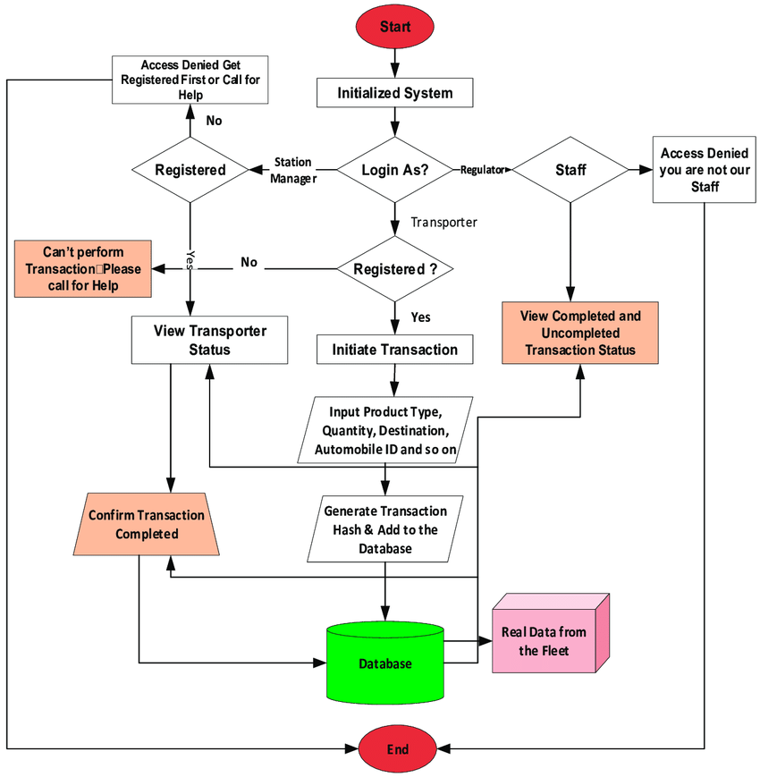

**5.2 SOLUTION ARCHITECTURE**

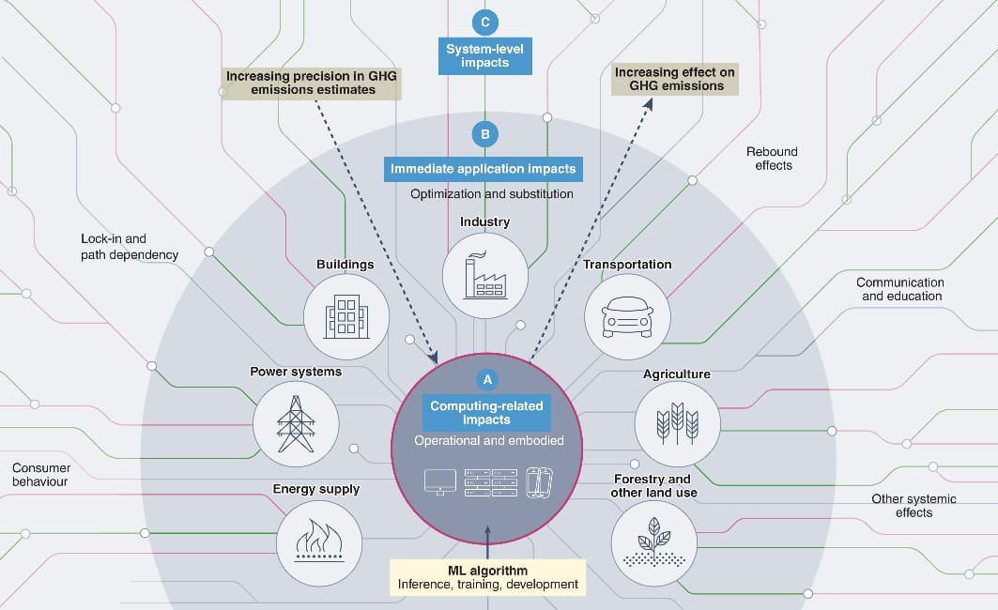

**6. PROJECT PLANNING &SCHEDULING**

**6.1 TECHNICAL ARCHITECTURE**

* Block chain Network: Climate Track utilizes a distributed ledger technology (DLT) based on block chain to ensure the integrity and immutability of climate-related data. This network consists of multiple nodes that participate in the validation and consensus process.
* Smart Contracts: Climate Track employs smart contracts, which are self-executing agreements with predefined rules and conditions. These contracts automate the execution of climate-related transactions, such as carbon credit trading or renewable energy certificate issuance.
* Data Storage: Climate-related data, including emissions data, sustainability initiatives, and renewable energy generation, is securely stored on the block chain network. This decentralized storage ensures data integrity and prevents unauthorized modifications.
* APIs and Integration: Climate Track provides APIs (Application Programming Interfaces) to enable seamless integration with external systems and data sources. This allows for the collection and verification of climate data from various stakeholders, such as IOT devices, energy providers, and government databases.
* User Interface: Climate Track offers a user-friendly interface that allows stakeholders to interact with the platform. This interface enables data submission, access to reports and analytics, and the ability to track progress towards climate goals.
* Security and Privacy: Climate Track incorporates robust security measures to protect sensitive climate data. Encryption techniques, access controls, and authentication mechanisms are implemented to ensure data privacy and prevent unauthorized access.
* Analytics and Reporting: Climate Track includes analytics and reporting capabilities to generate insights and visualize climate-related data. This helps stakeholders monitor their progress, identify trends, and make informed decisions regarding climate action Overall, the technical architecture of Climate Track combines block chain technology, data storage systems, APIs, and user interfaces to create a secure, transparent, and efficient platform for tracking and managing climate-related data .

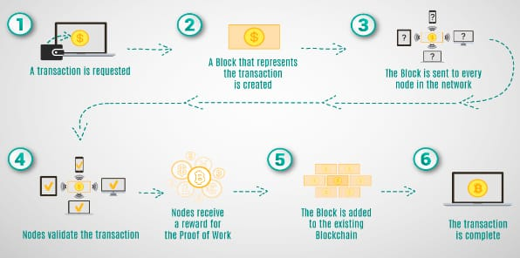

**6.2 Sprint Planning and Estimation:**

Sprint planning and estimation for Climate Track would involve breaking down the development tasks and features into manageable units of work that can be completed within a sprint, typically a time-boxed period of 1-4 weeks.

Here is a general outline of the process:

* Product Backlog: Start by maintaining a prioritized list of features, enhancements, and bug fixes in the product backlog. This backlog should be regularly reviewed and updated based on user feedback, market demands, and business priorities.
* Sprint Goal: Define a clear goal for each sprint that aligns with the overall objectives of Climate Track. This goal should be specific, measurable, achievable, relevant, and time-bound (SMART).
* Sprint Planning Meeting: Conduct a sprint planning meeting where the development team, product owner, and other stakeholders collaborate to select the top-priority items from the product backlog for the upcoming sprint. The team should discuss and understand the requirements, dependencies, and acceptance criteria for each selected item.
* Task Breakdown: Once the sprint backlog is defined, the development team breaks down the selected items into smaller tasks or user stories. These tasks should be granular enough to estimate and track progress effectively. Each task should have a clear definition of done.
* Estimation: Estimate the effort required for each task using a suitable estimation technique, such as story points or hours. The development team should consider factors like complexity, dependencies, and their past velocity while estimating.
* Capacity Planning: Determine the team's capacity for the sprint by considering factors like team size, individual availability, and any planned leave or holidays. Ensure that the team hassufficient capacity to complete the selected items within the sprint.
* Sprint Backlog: Create a sprint backlog that includes the selected items, their estimated effort, and the team's capacity. This backlog serves as a plan for the sprint and helps in tracking progress.
* Sprint Execution: During the sprint, the development team works on the tasks in the sprint backlog, following agile practices like daily stand-up meetings, continuous integration, and regular communication with stakeholders.
* Sprint Review and Retrospective: At the end of the sprint, conduct a sprint review to demonstrate the completed work to stakeholders and gather feedback. Also, hold a sprint retrospective to reflect on the sprint's successes, challenges, and areas for improvement.
* Repeat: Iterate through the sprint planning and execution process for subsequent sprints, continuously refining and improving the product based on feedback and changing requirements.
* It's important to note that the specific sprint planning and estimation process for ClimateTrack may vary based on the team's preferences, project complexity, and organizational context.

**7. CODING & SOLUTION**

pragma solidity ^0.8.0;

contract climateChange{

    struct ClimateData {

        uint timestamp;

        string details;

    }

    mapping(address => ClimateData) public climateRecords;

    function addClimateData(string memory details) public {

        ClimateData memory newData = ClimateData(block.timestamp, details);

        climateRecords[msg.sender] = newData;

    }

    function getClimateData() public view returns (ClimateData memory) {

        return climateRecords[msg.sender];

    }

    function updateClimateData(string memory details) public {

        climateRecords[msg.sender].details = details;

    }

    // These are very basic functions written to carry out the operation

}

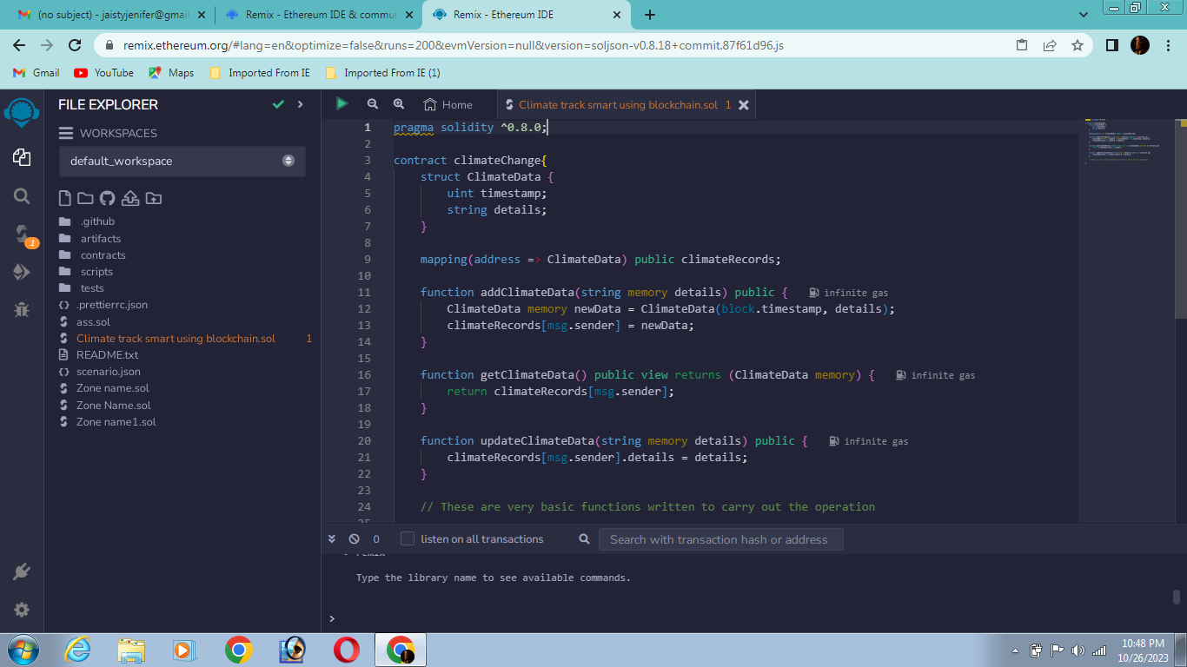

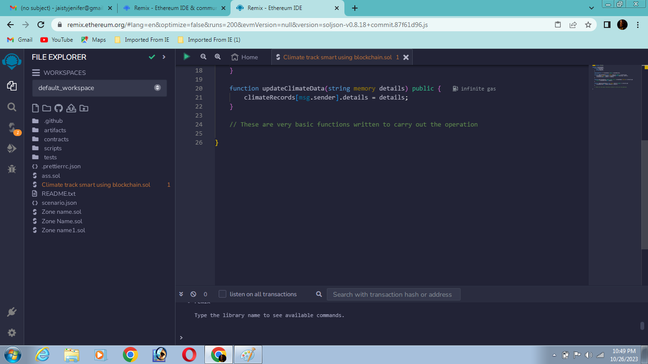

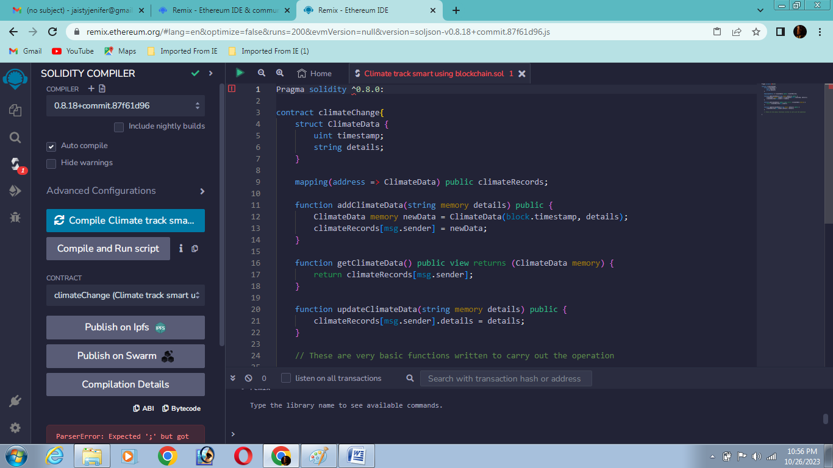

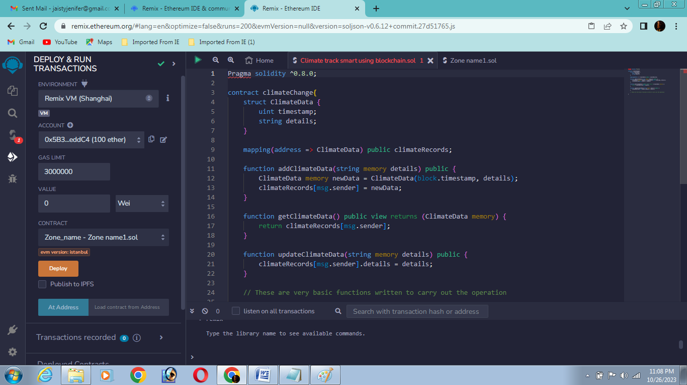

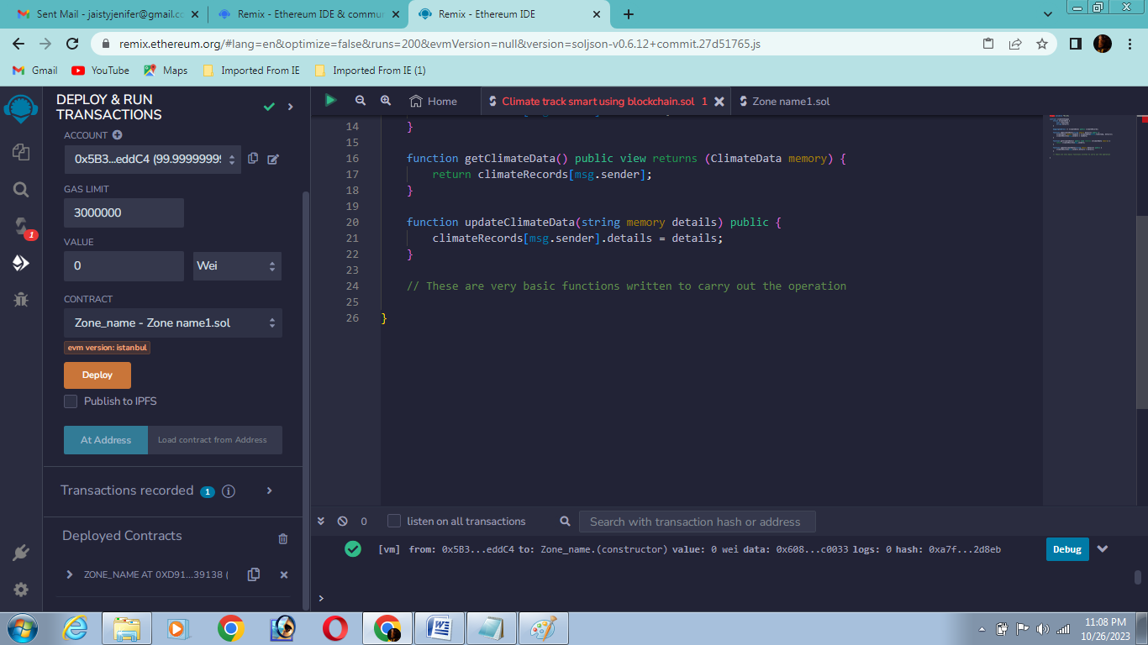

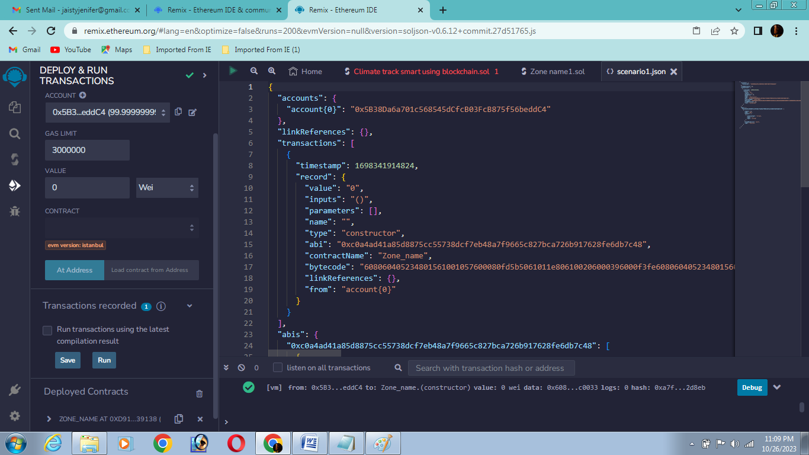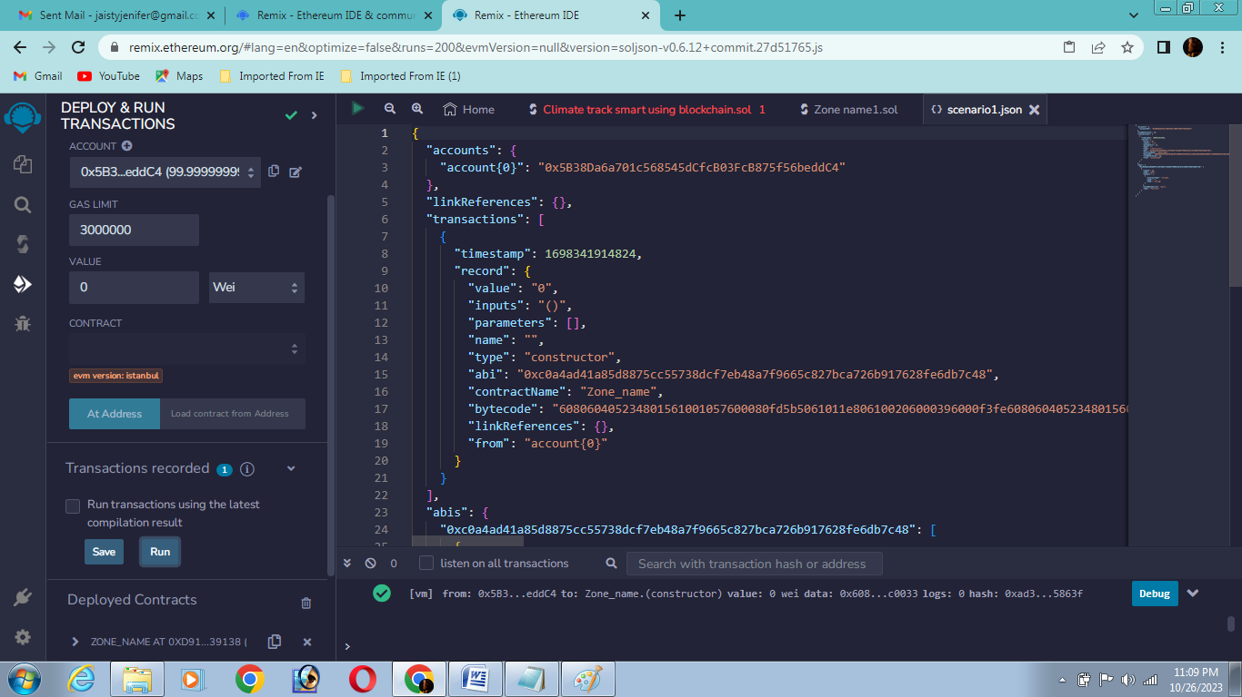

**7.1 FEATURE 1**

* Transparent and verifiable tracking of carbon emissions Block chain technology can be used to create a transparent and verifiable record of carbon emissions throughout the supply chain. This can help to reduce fraud and ensure that businesses are meeting their sustainability goals. Here is a simplified example of how this could work:
* Each product is given a unique identifier that is linked to a block chain record. As the product moves through the supply chain, each participant records their carbon emissions associated with that product on the block chain. This record is then tamper-proof and can be easily accessed by any stakeholder. This system would allow businesses to track their carbon emissions accurately and report them to customers and regulators with confidence. It would also help to identify areas where emissions can be reduced.

**7.2 FEATURE 2**

* Smart contracts are self-executing contracts that can be used to automate transactions and agreements. They can be used to create incentives for businesses and individuals to reduce their carbon emissions.
* Here is an example of how this could work:
* A company enters into a smart contract with its suppliers, agreeing to pay them a premium for products that have a lower carbon footprint.
* The smart contract uses the block chain record of carbon emissions to verify that the products meet the required standards.
* If the products do meet the standards, the smart contract automatically releases the premium payment to the suppliers.
* This system would incentivize suppliers to reduce their carbon emissions in order to earn higher profits. It would also help the company to achieve its own sustainability goals.
* These are just two examples of how block chain technology can be used to create a smart climate tracking system. As the technology continues to develop, we can expect to see even more innovative and effective solutions emerge.
* Here are some additional benefits of using block chain technology for climate tracking:
* Improved data security and integrity: Block chain is a distributed ledger technology, which means that data is stored on multiple computers and is constantly verified. This makes it very difficult to tamper with or hack block chain data.

**7.3 DATABASE SCHEMA (if applicable)**

* This database schema would allow Climate Track to store climate data measurements in a decentralized and secure manner. The block chain hash column would allow Climate Track smart to verify the authenticity of each measurement by checking it against the block chain.
* Climate Track Smart could use this database schema to store climate data measurements from all over the world. The block chain would ensure that the data tamper-proof and secure.

**8. PERFORMANCE TESTING**

|  |  |  |  |
| --- | --- | --- | --- |
| SI.NO | PARAMETER | VALUES | SCREENSHOT |
| 1. | Information gathering | Setup all the Prerequisite:  1.Node js |  |
|  |  | 2.VS CODE |  |
|  |  | 3. Metamask |  |
| 2. | Extract the zip files | Open to VS code |  |
| 3. | RemixIDE platform exploring | Deploy and run the transaction. By selecting the environment  - inject the MetaMask. |  |

|  |  |  |  |
| --- | --- | --- | --- |
| 4. | Open file explorer | Open the extracted file and click on the folder.  Open cmd enter commends  1. npm install  2. npm bootstrap  3. npm start |  |
| 5. | {LOCALHOST IP ADDRESS} | Copy the address and it to chrome so you can see the front end of your project |  |

**9. RESULTS**

**9.1 OUTPUT SCREENSHOTS**

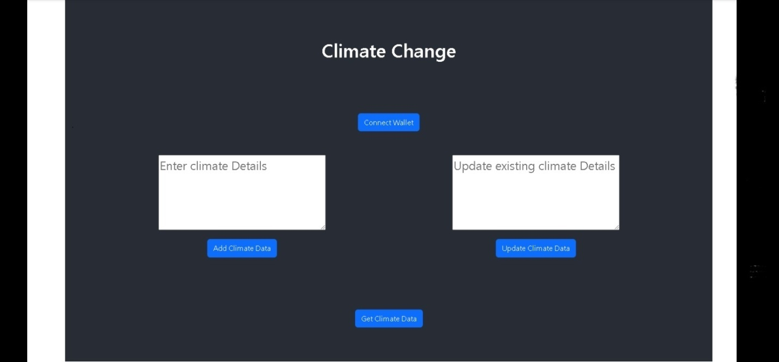

**10. ADVANTAGES & DISADVANTAGES**

**ADVANTAGES:**

* Block chain provides a temper proof and transparent record of all transaction making it possible.
* Smart contracts can be used to automate the tracking, reporting and verification of a climate related data.
* Instant accessibility, absolute anonymity, Permanent Ledger, accurate tracking supply is central bank independent.
* Cost reduction, secure and Private.
* Decentralization/ increased transparency.
* Lower transaction cost, faster processing of transaction, World Wide acceptance.

**DISAVNTAGES:**

* Rising cost of mining, power consumption.
* Environmental consequences.
* Market manipulation: pump/dump trading, Regulatory concerns implications.
* Scalability and cyber security issues, no protection in case of loss.
* Challenges of market fluctuations, difficulty to understand, complex technology.
* Competing platforms, implementation challenges, Has no physical form or intrinsic value.

**11. CONCLUTION**

* Climate track smart using block chain is a promising approach to addressing climate change. Block chain technology can help to improve the transparency, accountability, and efficiency of climate action by providing a secure and tamper-proof record of emissions data.
* Block chain can also be used to create new and innovative climate solutions, such as carbon credit trading platforms and renewable energy markets.
* Overall, block chain has the potential to play a significant role in accelerating climate action and building a more sustainable future.
* Carbon Credit Trading: Block chain can be used to create a more transparent and efficient carbon credit trading market. This would make it easier for businesses to offset their emissions and invest in climate projects.
* While block chain is still a relatively new technology, it has the potential to revolutionize the way we track and manage climate data. By using block chain to create a more transparent, accountable, and efficient system for climate ac

**12. FUTURE SCOPE**

* Block chain technology has the potential to revolutionize the way we track and manage climate data. By providing a secure, transparent, and tamper-proof way to store and share data, block chain can help us to:
* Improve the accuracy and reliability of climate data. Increase the transparency of climate data. Block chain can provide a public record of climate data, making it easier for the public to scrutinize and verify data. This can help to build trust in the data and make it more useful for decision-making. Reduce the cost of tracking and managing climate data. Block chain can help to streamline the process of collecting, storing, and sharing climate data, making it more efficient and cost-effective.
* Here are some specific examples of how block chain can be used to track and manage climate data in the future:
* Carbon footprint tracking: Block chain can be used to track the carbon footprint of products and services throughout their entire life cycle, from raw materials extraction to transportation and disposal. This information can be used to identify and reduce emissions, and to make more informed purchasing decisions.
* Renewable energy tracking: Block chain can be used to track the generation and distribution of renewable energy.
* Climate offsetting: Block chain can be used to create a more efficient and transparent market for carbon offsets.
* Overall, block chain has the potential to play a significant role in the fight against climate change by making it easier and more efficient to track and manage climate data.
* As block chain technology continues to develop and mature, we can expect to see even more innovative and groundbreaking applications for climate tracking and management.

**13. APPENDIX**

* Block chain Technology Overview: Provide a brief explanation of block chain technology, including its key features such as decentralization, immutability, and transparency. Explain how block chain can be applied to the Climate Track project to enhance data security and integrity.
* Block chain Integration: Describe how block chain technology is integrated into the Climate Track project. Explain the specific use cases and functionalities that block chain enables, such as secure data storage, traceability of climate-related data, and smart contracts for automated transactions.
* Data Structure: Outline the data structure used in the block chain implementation for Climate Track. Explain how climate-related data is stored, organized, and linked together in blocks, ensuring the integrity and immutability of the information.
* Consensus Mechanism: Discuss the consensus mechanism employed in the block chain network for Climate Track. Explain how consensus is achieved among network participants to validate and verify transactions and ensure the accuracy of the data.
* Security Measures: Detail the security measures implemented in the block chain system for Climate Track. Discuss cryptographic techniques used to protect data privacy, prevent unauthorized access, and mitigate potential cyber threats.
* Smart Contracts: Explain the concept of smart contracts and their role in the Climate Track project. Describe how smart contracts are utilized to automate and enforce agreements, such as carbon credit trading or climate-related incentive programs.
* Benefits of Block chain Integration: Highlight the benefits of integrating block chain technology into the Climate Track project. Discuss how block chain enhances data transparency, trust, and accountability, while also reducing the reliance on intermediaries and improving efficiency.
* Challenges and Considerations: Address any challenges or considerations associated with implementing block chain in the Climate Track project. Discuss potential scalability issues, regulatory compliance, and the need for interoperability with existing systems.
* Future Developments: Provide insights into future developments and potential enhancements for the block chain integration in the Climate Track project. Discuss emerging trends and technologies that could further improve the project's effectiveness and impact.

**13.1 SOURCE CODE**

[

{

"inputs": [

{

"internalType": "string",

"name": "details",

"type": "string"

}

],

"name": "addClimateData",

"outputs": [],

"stateMutability": "nonpayable",

"type": "function"

},

{

"inputs": [

{

"internalType": "address",

"name": "",

"type": "address"

}

],

"name": "climateRecords",

"outputs": [

{

"internalType": "uint256",

"name": "timestamp",

"type": "uint256"

},

{

"internalType": "string",

"name": "details",

"type": "string"

}

],

"stateMutability": "view",

"type": "function"

},

{

"inputs": [],

"name": "getClimateData",

"outputs": [

{

"components": [

{

"internalType": "uint256",

"name": "timestamp",

"type": "uint256"

},

{

"internalType": "string",

"name": "details",

"type": "string"

}

],

"internalType": "struct climateChange.ClimateData",

"name": "",

"type": "tuple"

}

],

"stateMutability": "view",

"type": "function"

},

{

"inputs": [

{

"internalType": "string",

"name": "details",

"type": "string"

}

],

"name": "updateClimateData",

"outputs": [],

"stateMutability": "nonpayable",

"type": "function"

}

]

**13.2 GITHUB & PROJECT DEMO LINK**

**GithubLink:** [**https://github.com/ishajothi2002/Climate-track-smart-using-block-chain**](https://github.com/ishajothi2002/Climate-track-smart-using-block-chain)

**DemoLink: https://youtu.be/edosAPXkff8?feature=shared**